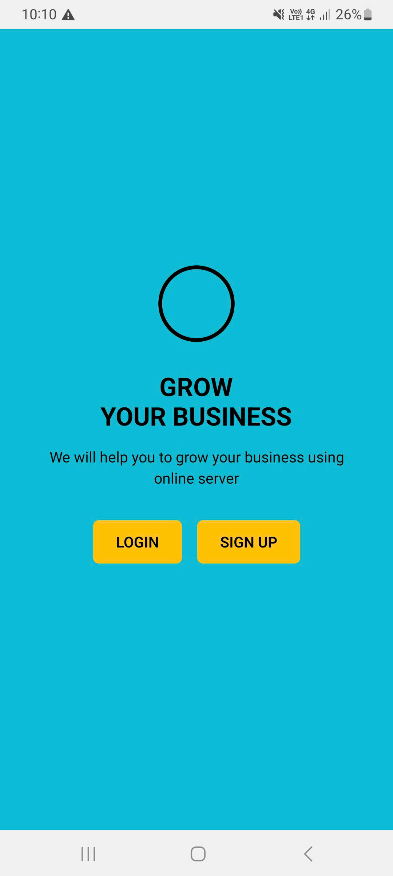

import { View, Text, TouchableOpacity, StyleSheet } from "react-native"

interface StartupPageProps {

  onNavigateToLogin: () => void

  onNavigateToLoginForm: () => void

  onNavigateToRegister: () => void

  onNavigateToYellowLogin: () => void

  onNavigateToWhiteLogin: () => void

}

export default function StartupPage({

  onNavigateToLogin,

  onNavigateToLoginForm,

  onNavigateToRegister,

  onNavigateToYellowLogin,

  onNavigateToWhiteLogin,

}: StartupPageProps) {

  return (

    <View style={styles.screen}>

      <View style={styles.content}>

        <View style={styles.circle} />

        <Text style={styles.title}>GROW{"\n"}YOUR BUSINESS</Text>

        <Text style={styles.subtitle}>We will help you to grow your business using{"\n"}online server</Text>

        <View style={styles.buttonContainer}>

          <TouchableOpacity style={styles.button} onPress={onNavigateToLoginForm}>

            <Text style={styles.buttonText}>LOGIN</Text>

          </TouchableOpacity>

          <TouchableOpacity style={styles.button} onPress={onNavigateToRegister}>

            <Text style={styles.buttonText}>SIGN UP</Text>

          </TouchableOpacity>

        </View>

        <View style={styles.loginOptionsContainer}>

          <Text style={styles.loginOptionsTitle}>Choose Login Style:</Text>

          <View style={styles.loginOptionsButtons}>

            <TouchableOpacity style={styles.yellowLoginButton} onPress={onNavigateToYellowLogin}>

              <Text style={styles.yellowLoginText}>Yellow Login</Text>

            </TouchableOpacity>

            <TouchableOpacity style={styles.whiteLoginButton} onPress={onNavigateToWhiteLogin}>

              <Text style={styles.whiteLoginText}>White Login</Text>

            </TouchableOpacity>

          </View>

        </View>

      </View>

    </View>

  )

}

const styles = StyleSheet.create({

  screen: {

    flex: 1,

    backgroundColor: "#00BCD4",

  },

  content: {

    flex: 1,

    padding: 32,

    alignItems: "center",

    justifyContent: "center",

  },

  circle: {

    width: 80,

    height: 80,

    backgroundColor: "transparent",

    borderRadius: 40,

    borderWidth: 4,

    borderColor: "#000",

    marginBottom: 32,

  },

  title: {

    fontSize: 24,

    fontWeight: "bold",

    color: "#000",

    textAlign: "center",

    marginBottom: 16,

    lineHeight: 28,

  },

  subtitle: {

    fontSize: 14,

    color: "#000",

    textAlign: "center",

    marginBottom: 32,

    lineHeight: 20,

  },

  buttonContainer: {

    flexDirection: "row",

    gap: 16,

    marginBottom: 32,

  },

  button: {

    backgroundColor: "#FFC107",

    paddingHorizontal: 24,

    paddingVertical: 12,

    borderRadius: 6,

  },

  buttonText: {

    color: "#000",

    fontWeight: "600",

    fontSize: 14,

  },

  loginOptionsContainer: {

    alignItems: "center",

    marginTop: 20,

  },

  loginOptionsTitle: {

    fontSize: 16,

    color: "#000",

    fontWeight: "600",

    marginBottom: 12,

  },

  loginOptionsButtons: {

    flexDirection: "row",

    gap: 12,

  },

  yellowLoginButton: {

    backgroundColor: "#FFD700",

    paddingHorizontal: 16,

    paddingVertical: 8,

    borderRadius: 4,

    borderWidth: 1,

    borderColor: "#000",

  },

  yellowLoginText: {

    color: "#000",

    fontWeight: "500",

    fontSize: 12,

  },

  whiteLoginButton: {

    backgroundColor: "#FFF",

    paddingHorizontal: 16,

    paddingVertical: 8,

    borderRadius: 4,

    borderWidth: 1,

    borderColor: "#007BFF",

  },

  whiteLoginText: {

    color: "#007BFF",

    fontWeight: "500",

    fontSize: 12,

  },

})

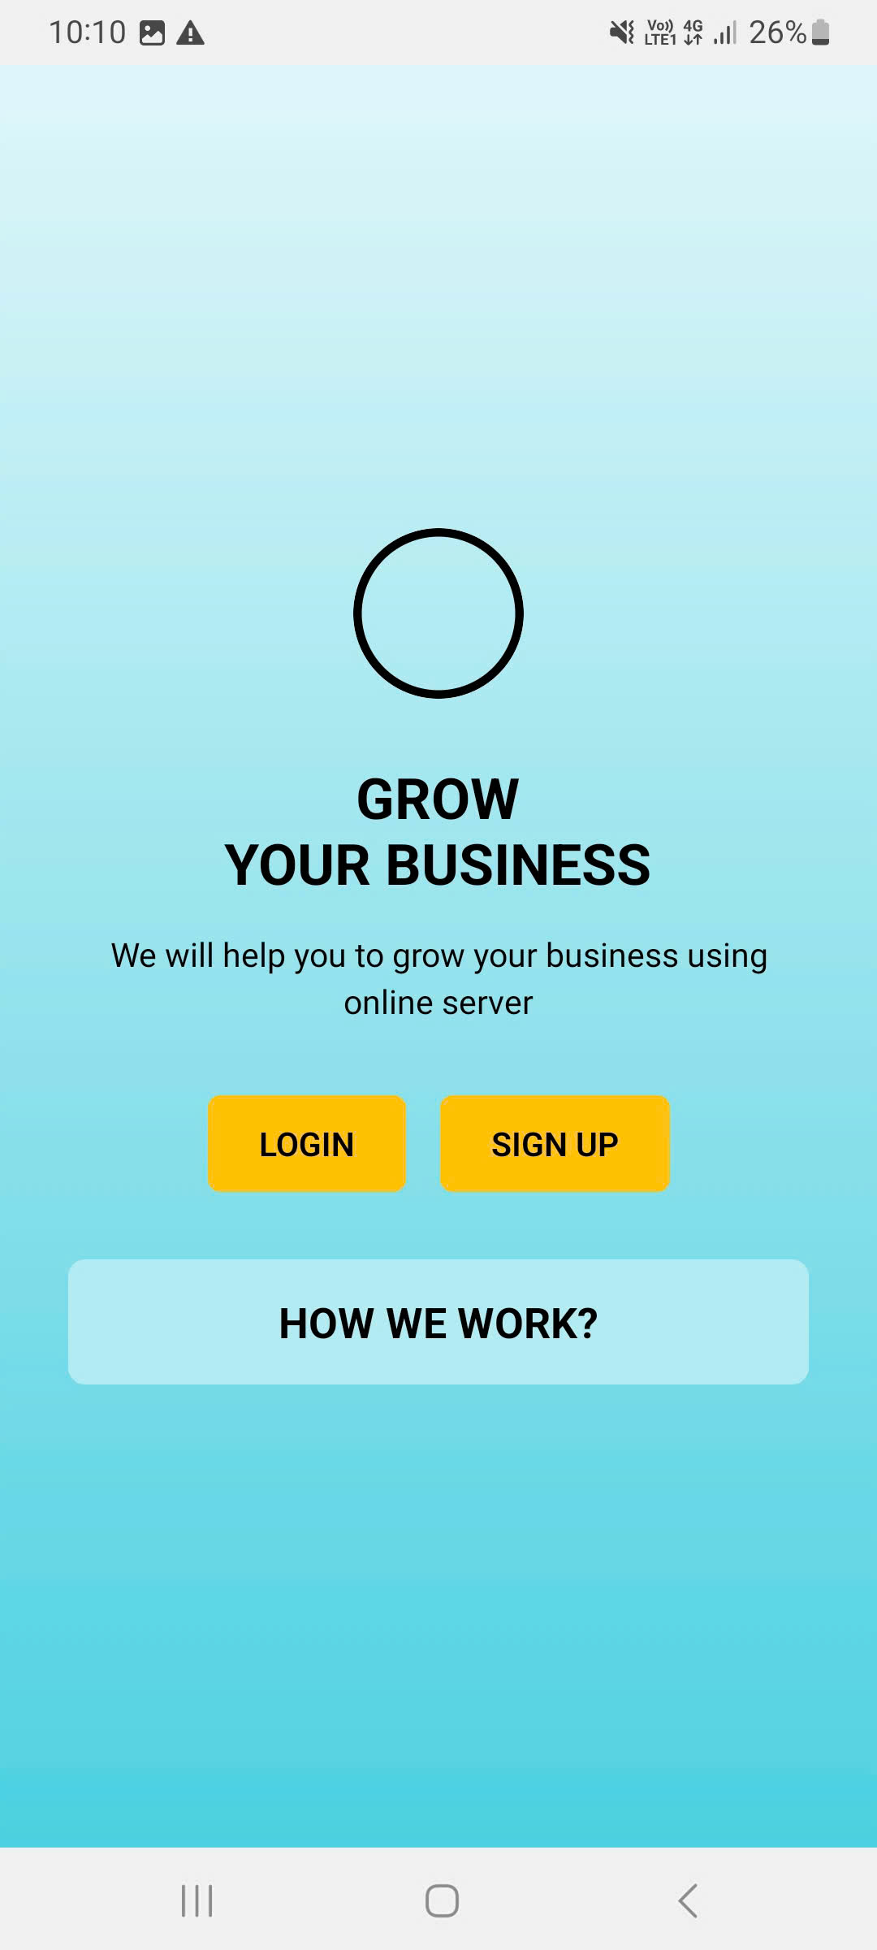

import { View, Text, TouchableOpacity, StyleSheet } from "react-native"

import { LinearGradient } from "expo-linear-gradient"

interface LoginPageProps {

  onNavigateToLoginForm: () => void

  onNavigateToRegister: () => void

}

export default function LoginPage({ onNavigateToLoginForm, onNavigateToRegister }: LoginPageProps) {

  return (

    <LinearGradient colors={["#E0F7FA", "#4DD0E1"]} style={styles.screen}>

      <View style={styles.content}>

        <View style={styles.circle} />

        <Text style={styles.title}>GROW{"\n"}YOUR BUSINESS</Text>

        <Text style={styles.subtitle}>We will help you to grow your business using{"\n"}online server</Text>

        <View style={styles.buttonContainer}>

          <TouchableOpacity style={styles.button} onPress={onNavigateToLoginForm}>

            <Text style={styles.buttonText}>LOGIN</Text>

          </TouchableOpacity>

          <TouchableOpacity style={styles.button} onPress={onNavigateToRegister}>

            <Text style={styles.buttonText}>SIGN UP</Text>

          </TouchableOpacity>

        </View>

        <View style={styles.howWeWorkContainer}>

          <Text style={styles.howWeWorkText}>HOW WE WORK?</Text>

        </View>

      </View>

    </LinearGradient>

  )

}

const styles = StyleSheet.create({

  screen: {

    flex: 1,

  },

  content: {

    flex: 1,

    padding: 32,

    alignItems: "center",

    justifyContent: "center",

  },

  circle: {

    width: 80,

    height: 80,

    backgroundColor: "transparent",

    borderRadius: 40,

    borderWidth: 4,

    borderColor: "#000",

    marginBottom: 32,

  },

  title: {

    fontSize: 24,

    fontWeight: "bold",

    color: "#000",

    textAlign: "center",

    marginBottom: 16,

    lineHeight: 28,

  },

  subtitle: {

    fontSize: 14,

    color: "#000",

    textAlign: "center",

    marginBottom: 32,

    lineHeight: 20,

  },

  buttonContainer: {

    flexDirection: "row",

    gap: 16,

    marginBottom: 32,

  },

  button: {

    backgroundColor: "#FFC107",

    paddingHorizontal: 24,

    paddingVertical: 12,

    borderRadius: 6,

  },

  buttonText: {

    color: "#000",

    fontWeight: "600",

    fontSize: 14,

  },

  howWeWorkContainer: {

    backgroundColor: "#B2EBF2",

    borderRadius: 8,

    padding: 16,

    width: "100%",

  },

  howWeWorkText: {

    fontSize: 18,

    fontWeight: "bold",

    color: "#000",

    textAlign: "center",

  },

})

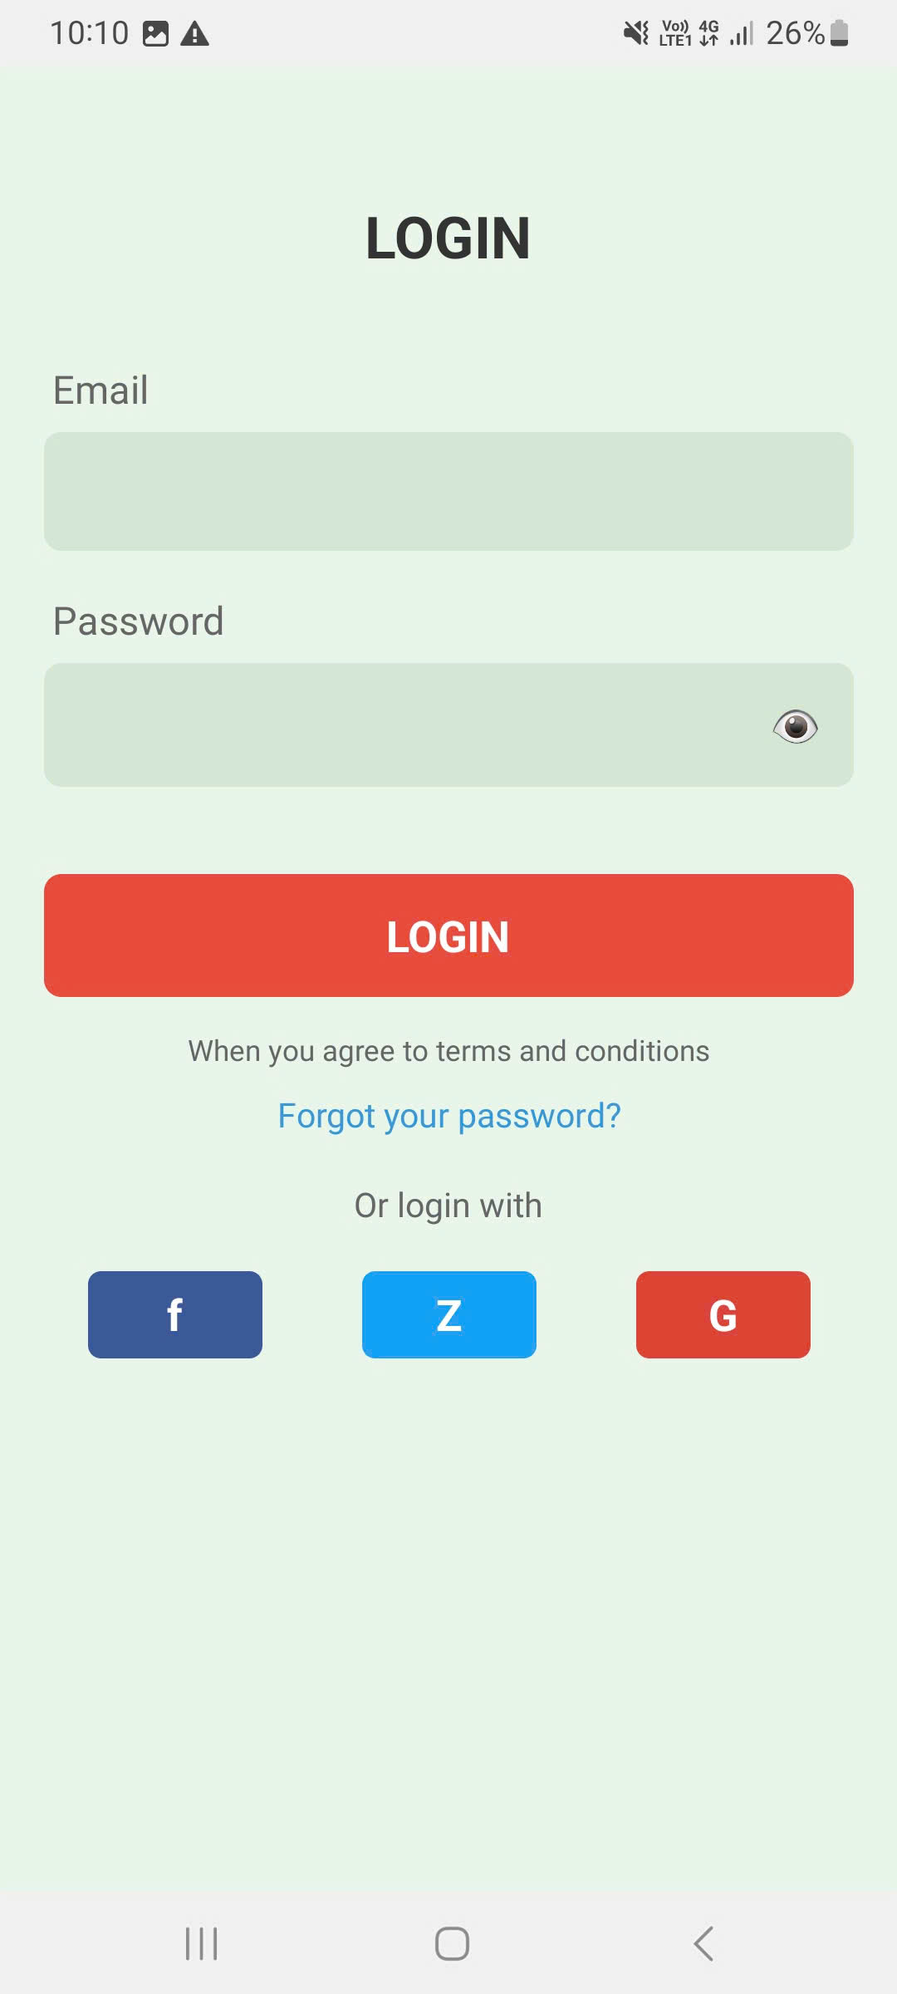

import { useState } from "react"

import { View, Text, TextInput, TouchableOpacity, StyleSheet } from "react-native"

interface LoginFormPageProps {

  onNavigateToForgotPassword: () => void

}

export default function LoginFormPage({ onNavigateToForgotPassword }: LoginFormPageProps) {

  const [email, setEmail] = useState("")

  const [password, setPassword] = useState("")

  const [showPassword, setShowPassword] = useState(false)

  return (

    <View style={styles.container}>

      <Text style={styles.title}>LOGIN</Text>

      <View style={styles.formContainer}>

        <View style={styles.inputContainer}>

          <Text style={styles.inputLabel}>Email</Text>

          <TextInput

            style={styles.input}

            value={email}

            onChangeText={setEmail}

            placeholder=""

            keyboardType="email-address"

            autoCapitalize="none"

          />

        </View>

        <View style={styles.inputContainer}>

          <Text style={styles.inputLabel}>Password</Text>

          <View style={styles.passwordContainer}>

            <TextInput

              style={styles.passwordInput}

              value={password}

              onChangeText={setPassword}

              placeholder=""

              secureTextEntry={!showPassword}

            />

            <TouchableOpacity style={styles.eyeButton} onPress={() => setShowPassword(!showPassword)}>

              <Text style={styles.eyeIcon}>👁</Text>

            </TouchableOpacity>

          </View>

        </View>

        <TouchableOpacity style={styles.loginButton}>

          <Text style={styles.loginButtonText}>LOGIN</Text>

        </TouchableOpacity>

        <Text style={styles.termsText}>When you agree to terms and conditions</Text>

        <TouchableOpacity onPress={onNavigateToForgotPassword}>

          <Text style={styles.forgotPassword}>Forgot your password?</Text>

        </TouchableOpacity>

        <Text style={styles.orText}>Or login with</Text>

        <View style={styles.socialContainer}>

          <TouchableOpacity style={[styles.socialButton, styles.facebookButton]}>

            <Text style={styles.socialButtonText}>f</Text>

          </TouchableOpacity>

          <TouchableOpacity style={[styles.socialButton, styles.zButton]}>

            <Text style={styles.socialButtonText}>Z</Text>

          </TouchableOpacity>

          <TouchableOpacity style={[styles.socialButton, styles.googleButton]}>

            <Text style={styles.socialButtonText}>G</Text>

          </TouchableOpacity>

        </View>

      </View>

    </View>

  )

}

const styles = StyleSheet.create({

  container: {

    flex: 1,

    backgroundColor: "#E8F5E8",

    paddingHorizontal: 20,

    paddingTop: 60,

  },

  title: {

    fontSize: 24,

    fontWeight: "bold",

    textAlign: "center",

    marginBottom: 40,

    color: "#333",

  },

  formContainer: {

    flex: 1,

  },

  inputContainer: {

    marginBottom: 20,

  },

  inputLabel: {

    fontSize: 16,

    color: "#666",

    marginBottom: 8,

    marginLeft: 4,

  },

  input: {

    backgroundColor: "#D4E6D4",

    borderRadius: 8,

    padding: 15,

    fontSize: 16,

    color: "#333",

  },

  passwordContainer: {

    flexDirection: "row",

    alignItems: "center",

    backgroundColor: "#D4E6D4",

    borderRadius: 8,

  },

  passwordInput: {

    flex: 1,

    padding: 15,

    fontSize: 16,

    color: "#333",

  },

  eyeButton: {

    padding: 15,

  },

  eyeIcon: {

    fontSize: 18,

  },

  loginButton: {

    backgroundColor: "#E74C3C",

    borderRadius: 8,

    padding: 15,

    alignItems: "center",

    marginTop: 20,

    marginBottom: 15,

  },

  loginButtonText: {

    color: "white",

    fontSize: 18,

    fontWeight: "bold",

  },

  termsText: {

    textAlign: "center",

    color: "#666",

    fontSize: 12,

    marginBottom: 10,

  },

  forgotPassword: {

    textAlign: "center",

    color: "#3498DB",

    fontSize: 14,

    marginBottom: 20,

  },

  orText: {

    textAlign: "center",

    color: "#666",

    fontSize: 14,

    marginBottom: 20,

  },

  socialContainer: {

    flexDirection: "row",

    justifyContent: "space-between",

    paddingHorizontal: 20,

  },

  socialButton: {

    width: 80,

    height: 40,

    borderRadius: 6,

    alignItems: "center",

    justifyContent: "center",

  },

  socialButtonText: {

    color: "white",

    fontSize: 18,

    fontWeight: "bold",

  },

  facebookButton: {

    backgroundColor: "#3B5998",

  },

  zButton: {

    backgroundColor: "#1DA1F2",

  },

  googleButton: {

    backgroundColor: "#DB4437",

  },

})

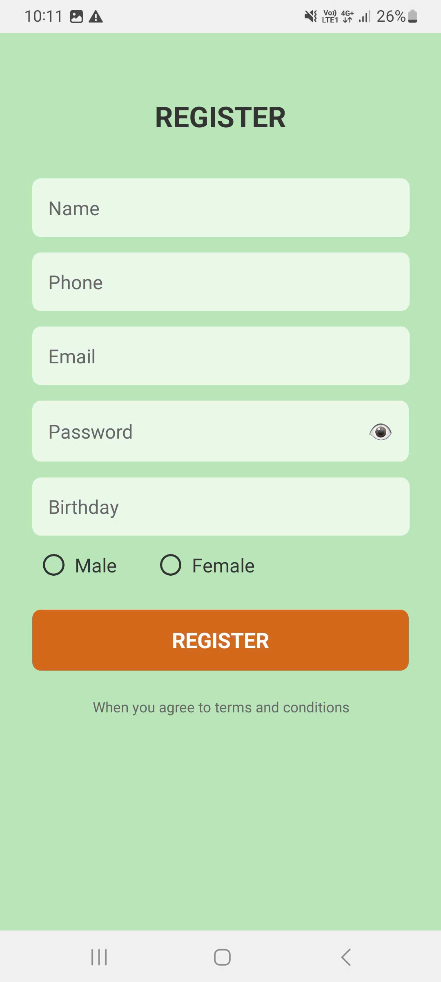

import { useState } from "react"

import { View, Text, TextInput, TouchableOpacity, StyleSheet } from "react-native"

import { SafeAreaView } from "react-native-safe-area-context"

export default function RegisterPage() {

  const [showPassword, setShowPassword] = useState(false)

  const [selectedGender, setSelectedGender] = useState("")

  return (

    <SafeAreaView style={styles.container}>

      <View style={styles.content}>

        <Text style={styles.title}>REGISTER</Text>

        <View style={styles.formContainer}>

          <TextInput style={styles.input} placeholder="Name" placeholderTextColor="#666" />

          <TextInput style={styles.input} placeholder="Phone" placeholderTextColor="#666" keyboardType="phone-pad" />

          <TextInput

            style={styles.input}

            placeholder="Email"

            placeholderTextColor="#666"

            keyboardType="email-address"

            autoCapitalize="none"

          />

          <View style={styles.passwordContainer}>

            <TextInput

              style={styles.passwordInput}

              placeholder="Password"

              placeholderTextColor="#666"

              secureTextEntry={!showPassword}

            />

            <TouchableOpacity style={styles.eyeButton} onPress={() => setShowPassword(!showPassword)}>

              <Text style={styles.eyeIcon}>👁</Text>

            </TouchableOpacity>

          </View>

          <TextInput style={styles.input} placeholder="Birthday" placeholderTextColor="#666" />

          <View style={styles.genderContainer}>

            <TouchableOpacity style={styles.genderOption} onPress={() => setSelectedGender("male")}>

              <View style={[styles.radioButton, selectedGender === "male" && styles.radioButtonSelected]} />

              <Text style={styles.genderText}>Male</Text>

            </TouchableOpacity>

            <TouchableOpacity style={styles.genderOption} onPress={() => setSelectedGender("female")}>

              <View style={[styles.radioButton, selectedGender === "female" && styles.radioButtonSelected]} />

              <Text style={styles.genderText}>Female</Text>

            </TouchableOpacity>

          </View>

          <TouchableOpacity style={styles.registerButton}>

            <Text style={styles.registerButtonText}>REGISTER</Text>

          </TouchableOpacity>

          <Text style={styles.termsText}>When you agree to terms and conditions</Text>

        </View>

      </View>

    </SafeAreaView>

  )

}

const styles = StyleSheet.create({

  container: {

    flex: 1,

    backgroundColor: "#B8E6B8",

  },

  content: {

    flex: 1,

    paddingHorizontal: 30,

    paddingTop: 60,

  },

  title: {

    fontSize: 24,

    fontWeight: "bold",

    textAlign: "center",

    marginBottom: 40,

    color: "#333",

  },

  formContainer: {

    flex: 1,

  },

  input: {

    backgroundColor: "rgba(255, 255, 255, 0.7)",

    borderRadius: 8,

    paddingHorizontal: 15,

    paddingVertical: 15,

    marginBottom: 15,

    fontSize: 16,

    color: "#333",

  },

  passwordContainer: {

    flexDirection: "row",

    alignItems: "center",

    backgroundColor: "rgba(255, 255, 255, 0.7)",

    borderRadius: 8,

    marginBottom: 15,

  },

  passwordInput: {

    flex: 1,

    paddingHorizontal: 15,

    paddingVertical: 15,

    fontSize: 16,

    color: "#333",

  },

  eyeButton: {

    paddingHorizontal: 15,

    paddingVertical: 15,

  },

  eyeIcon: {

    fontSize: 18,

  },

  genderContainer: {

    flexDirection: "row",

    marginBottom: 30,

    paddingHorizontal: 10,

  },

  genderOption: {

    flexDirection: "row",

    alignItems: "center",

    marginRight: 40,

  },

  radioButton: {

    width: 20,

    height: 20,

    borderRadius: 10,

    borderWidth: 2,

    borderColor: "#333",

    marginRight: 10,

    backgroundColor: "transparent",

  },

  radioButtonSelected: {

    backgroundColor: "#333",

  },

  genderText: {

    fontSize: 16,

    color: "#333",

  },

  registerButton: {

    backgroundColor: "#D2691E",

    borderRadius: 8,

    paddingVertical: 15,

    alignItems: "center",

    marginBottom: 15,

  },

  registerButtonText: {

    color: "white",

    fontSize: 18,

    fontWeight: "bold",

  },

  termsText: {

    textAlign: "center",

    fontSize: 12,

    color: "#666",

    marginTop: 10,

  },

})

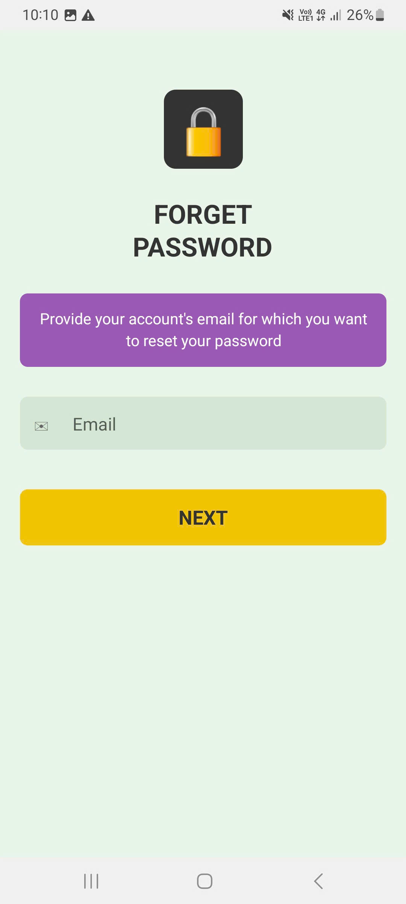

import { useState } from "react"

import { View, Text, TextInput, TouchableOpacity, StyleSheet } from "react-native"

interface ForgotPasswordPageProps {

  onNext: () => void

}

export default function ForgotPasswordPage({ onNext }: ForgotPasswordPageProps) {

  const [email, setEmail] = useState("")

  return (

    <View style={styles.container}>

      <View style={styles.iconContainer}>

        <View style={styles.lockIcon}>

          <Text style={styles.lockText}>🔒</Text>

        </View>

      </View>

      <Text style={styles.title}>FORGET{"\n"}PASSWORD</Text>

      <View style={styles.instructionContainer}>

        <Text style={styles.instructionText}>

          Provide your account's email for which you want to reset your password

        </Text>

      </View>

      <View style={styles.inputContainer}>

        <View style={styles.emailInputContainer}>

          <Text style={styles.emailIcon}>✉</Text>

          <TextInput

            style={styles.emailInput}

            value={email}

            onChangeText={setEmail}

            placeholder="Email"

            keyboardType="email-address"

            autoCapitalize="none"

          />

        </View>

      </View>

      <TouchableOpacity style={styles.nextButton} onPress={onNext}>

        <Text style={styles.nextButtonText}>NEXT</Text>

      </TouchableOpacity>

    </View>

  )

}

const styles = StyleSheet.create({

  container: {

    flex: 1,

    backgroundColor: "#E8F5E8",

    paddingHorizontal: 20,

    paddingTop: 60,

  },

  iconContainer: {

    alignItems: "center",

    marginBottom: 30,

  },

  lockIcon: {

    width: 80,

    height: 80,

    backgroundColor: "#333",

    borderRadius: 12,

    alignItems: "center",

    justifyContent: "center",

  },

  lockText: {

    fontSize: 40,

    color: "white",

  },

  title: {

    fontSize: 24,

    fontWeight: "bold",

    textAlign: "center",

    marginBottom: 30,

    color: "#333",

    lineHeight: 30,

  },

  instructionContainer: {

    backgroundColor: "#9B59B6",

    borderRadius: 8,

    padding: 15,

    marginBottom: 30,

  },

  instructionText: {

    color: "white",

    fontSize: 14,

    textAlign: "center",

    lineHeight: 20,

  },

  inputContainer: {

    marginBottom: 40,

  },

  emailInputContainer: {

    flexDirection: "row",

    alignItems: "center",

    backgroundColor: "#D4E6D4",

    borderRadius: 8,

    paddingHorizontal: 15,

  },

  emailIcon: {

    fontSize: 18,

    marginRight: 10,

    color: "#666",

  },

  emailInput: {

    flex: 1,

    padding: 15,

    fontSize: 16,

    color: "#333",

  },

  nextButton: {

    backgroundColor: "#F1C40F",

    borderRadius: 8,

    padding: 15,

    alignItems: "center",

    marginBottom: 40,

  },

  nextButtonText: {

    color: "#333",

    fontSize: 18,

    fontWeight: "bold",

  },

})

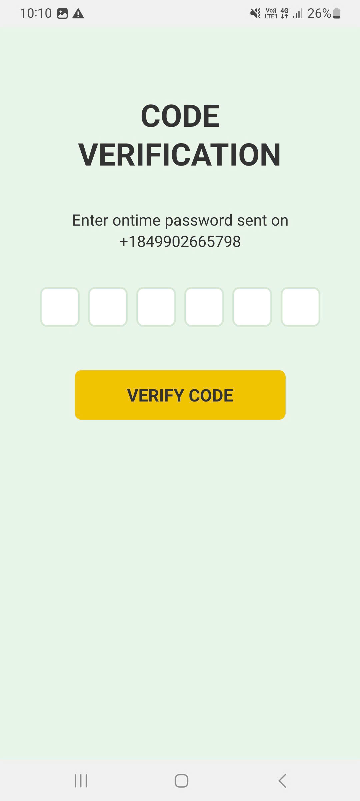

import { useState } from "react"

import { View, Text, TextInput, TouchableOpacity, StyleSheet } from "react-native"

export default function CodeVerificationPage() {

  const [code, setCode] = useState(["", "", "", "", "", ""])

  const handleCodeChange = (text: string, index: number) => {

    const newCode = [...code]

    newCode[index] = text

    setCode(newCode)

  }

  return (

    <View style={styles.container}>

      <Text style={styles.title}>CODE{"\n"}VERIFICATION</Text>

      <Text style={styles.subtitle}>Enter ontime password sent on{"\n"}+1849902665798</Text>

      <View style={styles.codeContainer}>

        {code.map((digit, index) => (

          <TextInput

            key={index}

            style={styles.codeInput}

            value={digit}

            onChangeText={(text) => handleCodeChange(text, index)}

            maxLength={1}

            keyboardType="numeric"

            textAlign="center"

          />

        ))}

      </View>

      <TouchableOpacity style={styles.verifyButton}>

        <Text style={styles.verifyButtonText}>VERIFY CODE</Text>

      </TouchableOpacity>

    </View>

  )

}

const styles = StyleSheet.create({

  container: {

    flex: 1,

    backgroundColor: "#E8F5E8",

    paddingHorizontal: 20,

    paddingTop: 80,

    alignItems: "center",

  },

  title: {

    fontSize: 32,

    fontWeight: "bold",

    textAlign: "center",

    marginBottom: 40,

    color: "#333",

    lineHeight: 40,

  },

  subtitle: {

    fontSize: 16,

    textAlign: "center",

    marginBottom: 40,

    color: "#333",

    lineHeight: 22,

  },

  codeContainer: {

    flexDirection: "row",

    justifyContent: "space-between",

    marginBottom: 50,

    paddingHorizontal: 10,

  },

  codeInput: {

    width: 45,

    height: 45,

    backgroundColor: "white",

    borderRadius: 8,

    borderWidth: 2,

    borderColor: "#D4E6D4",

    fontSize: 20,

    fontWeight: "bold",

    color: "#333",

    marginHorizontal: 5,

  },

  verifyButton: {

    backgroundColor: "#F1C40F",

    borderRadius: 8,

    paddingVertical: 15,

    paddingHorizontal: 60,

    alignItems: "center",

  },

  verifyButtonText: {

    color: "#333",

    fontSize: 18,

    fontWeight: "bold",

  },

})

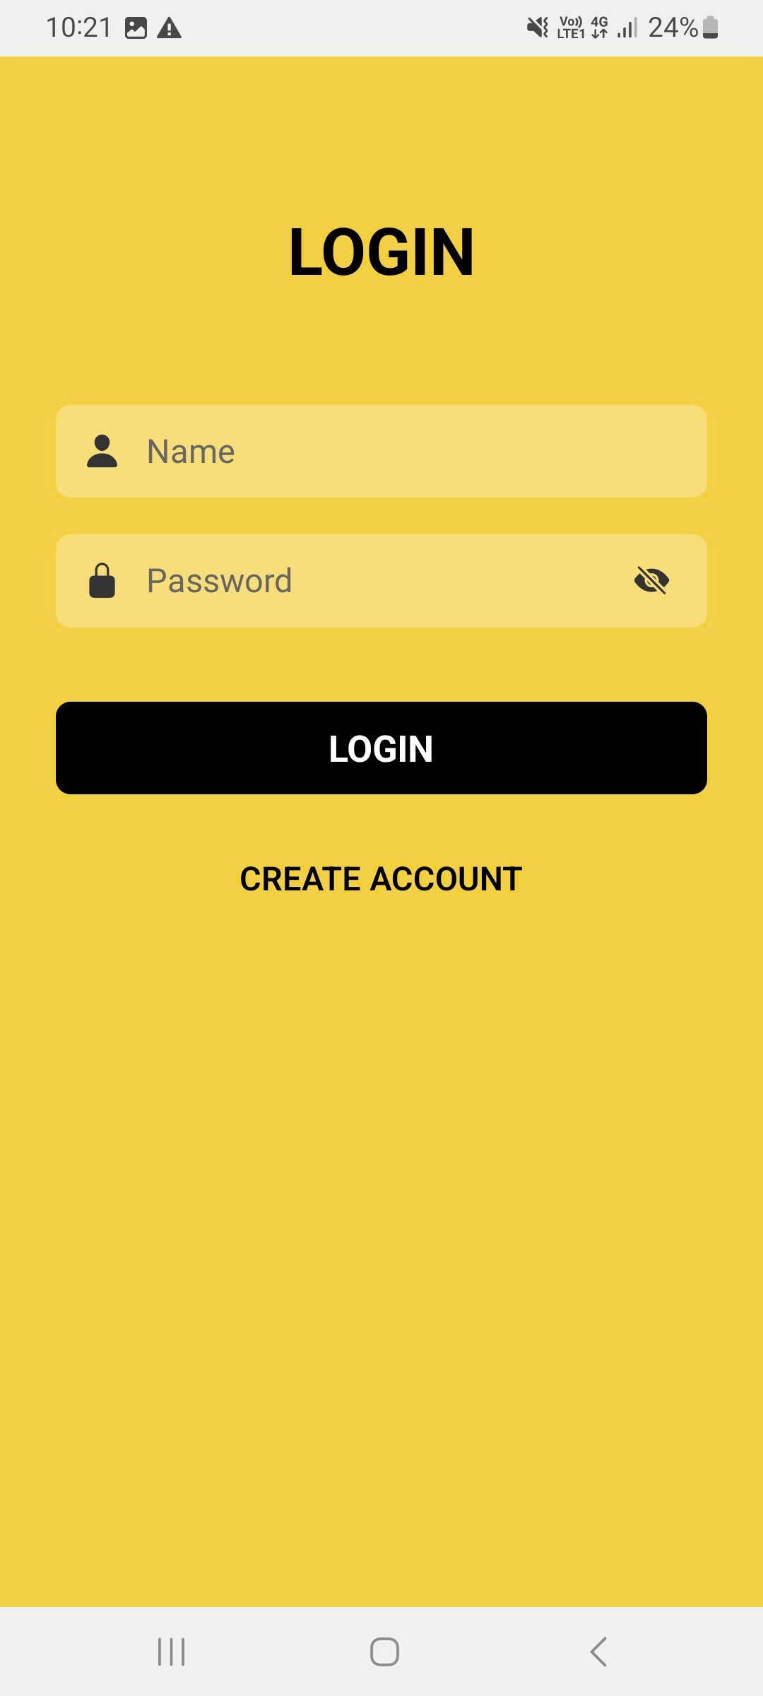

import { useState } from "react"

import { View, Text, TextInput, TouchableOpacity, StyleSheet } from "react-native"

import { Ionicons } from "@expo/vector-icons"

export default function YellowLoginPage() {

  const [showPassword, setShowPassword] = useState(false)

  const [name, setName] = useState("")

  const [password, setPassword] = useState("")

  return (

    <View style={styles.container}>

      <Text style={styles.title}>LOGIN</Text>

      <View style={styles.inputContainer}>

        <Ionicons name="person" size={20} color="#333" style={styles.inputIcon} />

        <TextInput

          style={styles.input}

          placeholder="Name"

          placeholderTextColor="#666"

          value={name}

          onChangeText={setName}

        />

      </View>

      <View style={styles.inputContainer}>

        <Ionicons name="lock-closed" size={20} color="#333" style={styles.inputIcon} />

        <TextInput

          style={styles.input}

          placeholder="Password"

          placeholderTextColor="#666"

          secureTextEntry={!showPassword}

          value={password}

          onChangeText={setPassword}

        />

        <TouchableOpacity style={styles.eyeIcon} onPress={() => setShowPassword(!showPassword)}>

          <Ionicons name={showPassword ? "eye" : "eye-off"} size={20} color="#333" />

        </TouchableOpacity>

      </View>

      <TouchableOpacity style={styles.loginButton}>

        <Text style={styles.loginButtonText}>LOGIN</Text>

      </TouchableOpacity>

      <TouchableOpacity style={styles.createAccountButton}>

        <Text style={styles.createAccountButtonText}>CREATE ACCOUNT</Text>

      </TouchableOpacity>

    </View>

  )

}

const styles = StyleSheet.create({

  container: {

    flex: 1,

    backgroundColor: "#F4D03F",

    paddingHorizontal: 30,

    paddingTop: 80,

  },

  title: {

    fontSize: 32,

    fontWeight: "bold",

    color: "#000",

    textAlign: "center",

    marginBottom: 60,

  },

  inputContainer: {

    flexDirection: "row",

    alignItems: "center",

    backgroundColor: "rgba(255, 255, 255, 0.3)",

    borderRadius: 8,

    marginBottom: 20,

    paddingHorizontal: 15,

    height: 50,

  },

  inputIcon: {

    marginRight: 10,

  },

  input: {

    flex: 1,

    fontSize: 16,

    color: "#333",

  },

  eyeIcon: {

    padding: 5,

  },

  loginButton: {

    backgroundColor: "#000",

    borderRadius: 8,

    height: 50,

    justifyContent: "center",

    alignItems: "center",

    marginTop: 20,

    marginBottom: 20,

  },

  loginButtonText: {

    color: "#fff",

    fontSize: 18,

    fontWeight: "bold",

  },

  createAccountButton: {

    backgroundColor: "transparent",

    borderRadius: 8,

    height: 50,

    justifyContent: "center",

    alignItems: "center",

  },

  createAccountButtonText: {

    color: "#000",

    fontSize: 16,

    fontWeight: "600",

  },

})

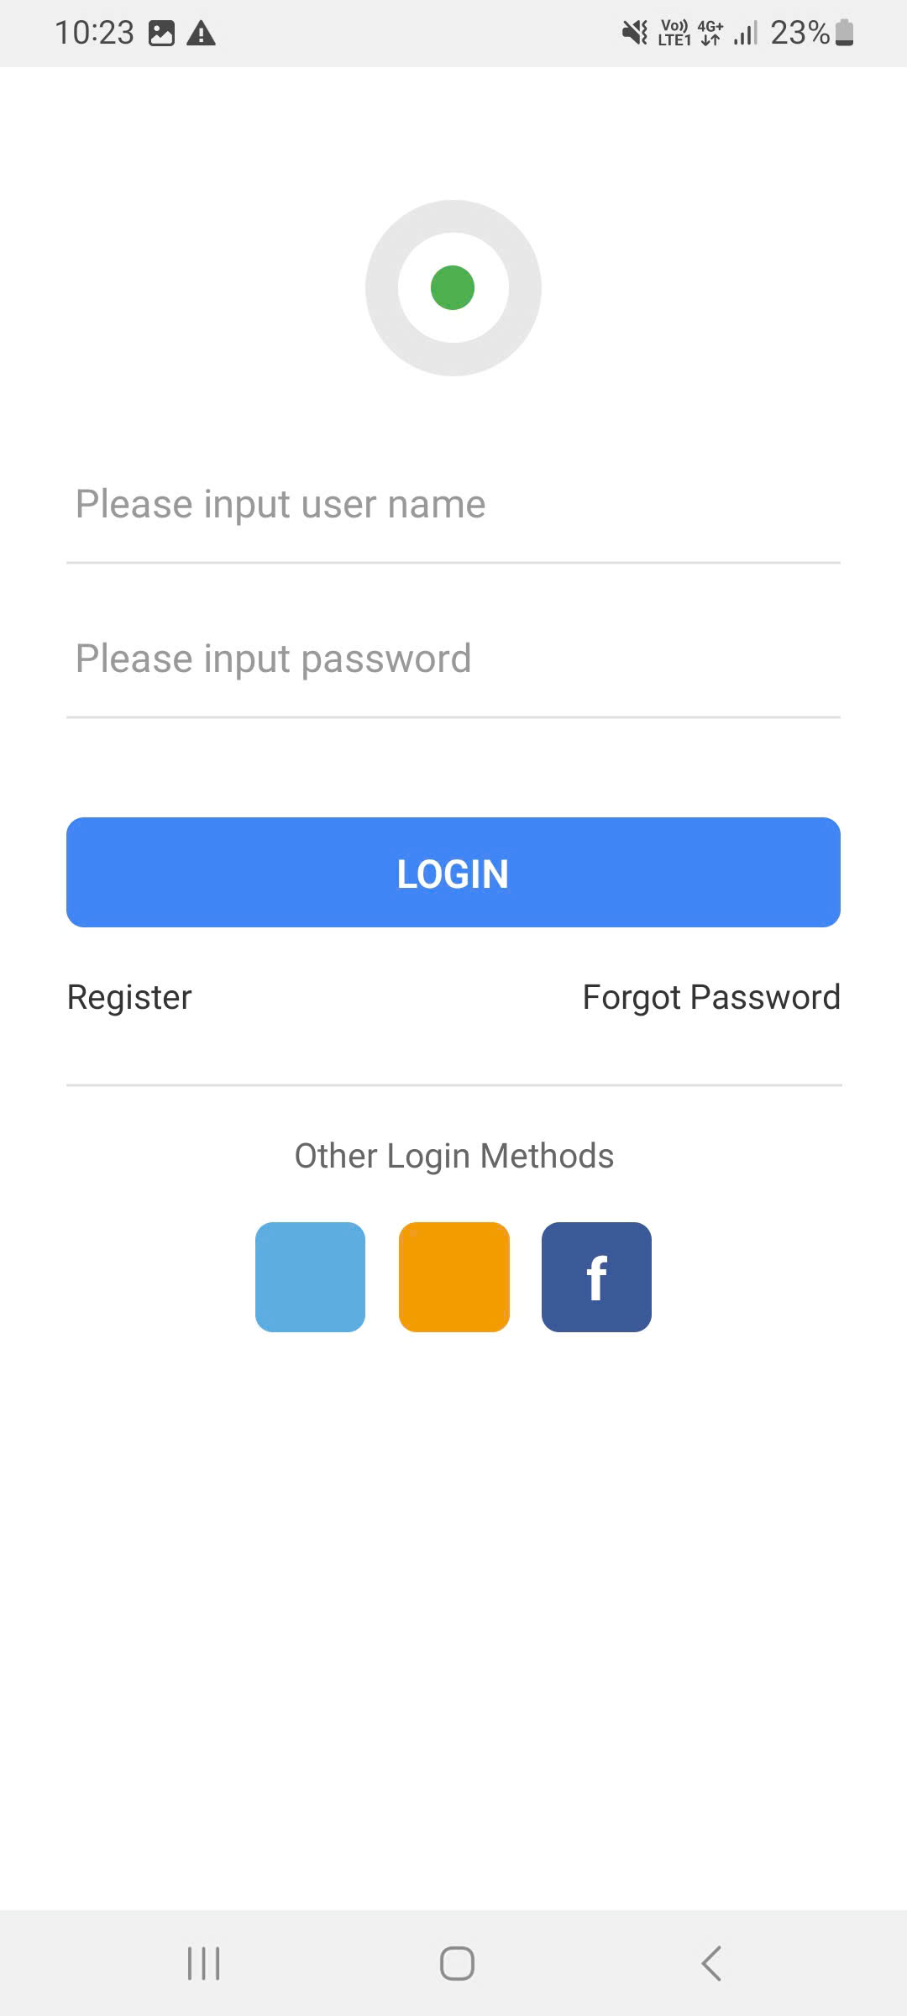

import { useState } from "react"

import { View, Text, TextInput, TouchableOpacity, StyleSheet } from "react-native"

import { Ionicons } from "@expo/vector-icons"

export default function WhiteLoginPage() {

  const [userName, setUserName] = useState("")

  const [password, setPassword] = useState("")

  return (

    <View style={styles.container}>

      <View style={styles.logoContainer}>

        <View style={styles.eyeBackground}>

          <View style={styles.eyeball}>

            <View style={styles.pupil} />

          </View>

        </View>

      </View>

      <View style={styles.formContainer}>

        <View style={styles.inputContainer}>

          <Ionicons name="person-outline" size={20} color="#999" style={styles.inputIcon} />

          <TextInput

            style={styles.input}

            placeholder="Please input user name"

            placeholderTextColor="#999"

            value={userName}

            onChangeText={setUserName}

          />

        </View>

        <View style={styles.inputContainer}>

          <Ionicons name="lock-closed-outline" size={20} color="#999" style={styles.inputIcon} />

          <TextInput

            style={styles.input}

            placeholder="Please input password"

            placeholderTextColor="#999"

            secureTextEntry

            value={password}

            onChangeText={setPassword}

          />

        </View>

        <TouchableOpacity style={styles.loginButton}>

          <Text style={styles.loginButtonText}>LOGIN</Text>

        </TouchableOpacity>

        <View style={styles.linksContainer}>

          <TouchableOpacity>

            <Text style={styles.linkText}>Register</Text>

          </TouchableOpacity>

          <TouchableOpacity>

            <Text style={styles.linkText}>Forgot Password</Text>

          </TouchableOpacity>

        </View>

        <Text style={styles.otherMethodsText}>Other Login Methods</Text>

        <View style={styles.socialContainer}>

          <TouchableOpacity style={[styles.socialButton, { backgroundColor: "#5DADE2" }]}>

            <Ionicons name="person" size={24} color="#fff" />

          </TouchableOpacity>

          <TouchableOpacity style={[styles.socialButton, { backgroundColor: "#F39C12" }]}>

            <Ionicons name="wifi" size={24} color="#fff" />

          </TouchableOpacity>

          <TouchableOpacity style={[styles.socialButton, { backgroundColor: "#3B5998" }]}>

            <Text style={styles.facebookText}>f</Text>

          </TouchableOpacity>

        </View>

      </View>

    </View>

  )

}

const styles = StyleSheet.create({

  container: {

    flex: 1,

    backgroundColor: "#fff",

    paddingHorizontal: 30,

  },

  logoContainer: {

    alignItems: "center",

    marginTop: 60,

    marginBottom: 40,

  },

  eyeBackground: {

    width: 80,

    height: 80,

    borderRadius: 40,

    backgroundColor: "#E8E8E8",

    justifyContent: "center",

    alignItems: "center",

  },

  eyeball: {

    width: 50,

    height: 50,

    borderRadius: 25,

    backgroundColor: "#fff",

    justifyContent: "center",

    alignItems: "center",

    position: "relative",

  },

  pupil: {

    width: 20,

    height: 20,

    borderRadius: 10,

    backgroundColor: "#4CAF50",

  },

  formContainer: {

    flex: 1,

  },

  inputContainer: {

    flexDirection: "row",

    alignItems: "center",

    borderBottomWidth: 1,

    borderBottomColor: "#E0E0E0",

    marginBottom: 25,

    paddingBottom: 10,

  },

  inputIcon: {

    marginRight: 15,

  },

  input: {

    flex: 1,

    fontSize: 16,

    color: "#333",

    paddingVertical: 5,

  },

  loginButton: {

    backgroundColor: "#4285F4",

    borderRadius: 8,

    height: 50,

    justifyContent: "center",

    alignItems: "center",

    marginTop: 20,

    marginBottom: 20,

  },

  loginButtonText: {

    color: "#fff",

    fontSize: 16,

    fontWeight: "600",

  },

  linksContainer: {

    flexDirection: "row",

    justifyContent: "space-between",

    marginBottom: 30,

  },

  linkText: {

    color: "#333",

    fontSize: 14,

  },

  otherMethodsText: {

    textAlign: "center",

    color: "#666",

    fontSize: 14,

    marginBottom: 20,

    borderTopWidth: 1,

    borderTopColor: "#E0E0E0",

    paddingTop: 20,

  },

  socialContainer: {

    flexDirection: "row",

    justifyContent: "center",

    gap: 15,

  },

  socialButton: {

    width: 50,

    height: 50,

    borderRadius: 8,

    justifyContent: "center",

    alignItems: "center",

  },

  facebookText: {

    color: "#fff",

    fontSize: 24,

    fontWeight: "bold",

  },

})